<COMPANY OR PROJECT LOGO>

<Project Name>

<Project Reference>

RESOURCE MANAGEMENT PLAN

Version <1.0>

<dd/mm/yyyy>

Document Control

Document Information

 | Information
Document Id | [Document Management System #]
Document Owner | [Owner Name]
Issue Date | [Date]
Last Saved Date | [Date]
File Name | [Name]

Document History

Version | Issue Date | Changes
[1.0] | [Date] | [Section, Page(s) and Text Revised]

Document Approvals

Role | Name© | Signature | Date
Project Sponsor
Project Review Group
Project Manager©
Quality Manager
(if applicable)
Procurement Manager
(if applicable)
Communications Manager
(if applicable)
Project Office Manager
(if applicable)

Table of Contents
<Project Name> i
<Project Reference> i
RESOURCE MANAGEMENT PLAN i
Version <1.0> i
<dd/mm/yyyy> i
Document Control i
Document Information i
Document History i
Document Approvals i
Template Guide 1
Team identification 2
team acquistion 2
team management 2
project organisation chart 3
roles and responsibilities 3
training requirements 4
rewards and recognition 4
team development and building 4
EQUIPMENT / MATERIALS identification and estimates 4
EQUIPMENT / MATERIALS resource acquisition 5
EQUIPMENT / MATERIALS resource management 5
Appendices 5
DOWNLOAD MORE PROJECT TEMPLATES 5

Template Guide
How to use this template
This is a guide to the common sections included in a Procurement management plan. Sections may be added, removed, or amended to suit your project. Example tables have been added (where relevant) these are just a suggestion; you may decide to format these sections differently.
Text in Blue italics is designed to assist you in completing the template. Delete this text before sharing the final document.

Team identification
<Document how the project team will be identified. For example, how the skills sets needed will be identified and the levels of skill. For example,
- Review the requirements, context, approach, location etc. and identify any custom components.
- Establish if similar tasks have been completed and who by.
- List skill sets needed.
You might use a table like the one below.>
Requirement/component | Skills needed | Role/SME description
Custom API | Prior experience, REST, JSON, CSS, html, JScript, stack. | Developer (L4)
Data import | Manipulate .csv data using Python. | Developer (L4)
Network set up | Network configuration | Engineer

team acquistion
<Describe how the project team members will be recruited/acquired>.
Role or SME | Person or team if known | Acquisition
Developer (L4) | Global Services Team | Resource Manager
Consultant | Local Consulting Team | Resource Manager
Security SME | Acme Security Company | Contract Acme Security Company (on approved supplier list)
Project Manager | Unknown | New recruit on 3-month contract. Project Sponsor to manage process.

team management
<Document how the team members will be managed during the project, including how performance will be managed. For example,>
Line management of all project team members will remain with their direct line manager, but allocation of project work will be the project manager’s responsibility. Any performance issues will be raised with their direct line manager.
Project team members will report on project progress to the project manager cc’ing their line manager. Clashes in work priorities will be resolved by the project manager, and line manager working together with the resource manager.

project organisation chart
<Create an organization chart showing the project hierarchy. An example is shown below.>
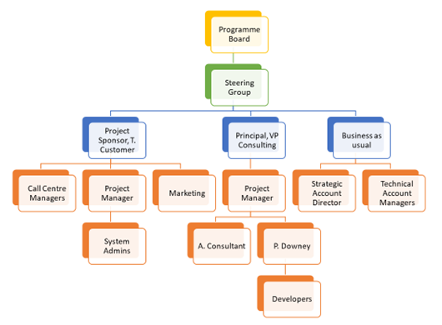

roles and responsibilities
<Describe the project team roles and their responsibilities including qualifications and competencies. For example,>
Role | Authority | Responsibility | Qualifications | Competencies
<Enter the role or job title> | <What the role is authorized to do> | <What tasks and outcomes the role is responsible for> | <Qualifications required/expected> | <Any specific things required for this project.>
Product consultant | Change default configuration of the product. | Understand customer goals & configure to suit. | Certified Product Administrator | German speaker.
Project Manager | Cost sign-off 1.5k. Decision on time and cost within project tolerances. | Day to day management of the project. | PMP qualified. | Ideally German speaker not essential.

training requirements
<Describe any training required for the project team members. For example, some federal or government projects will require security certifications or clearance. From fall 2020 the Department of Defense requires all contacts to have CMMC accreditation.>

rewards and recognition
<Describe any reward or recognition that applies to this project. For example, company award schemes or professional awards like PMI Project of the Year Award.>

team development and building
<Note any team development activities that will take place before or during the project. For example, if junior team members will shadow more experienced colleagues. Also describe any team building activities. For example, kick off drinks or team lunches etc.>

EQUIPMENT / MATERIALS identification and estimates
<Describe how materials, equipment and supplies needed for the project will be identified. For example, through review of the project requirements and statement of work. An example table for identified physical resources is shown below.>
Cost code | Description | Spec. | Quantity | Proposed supplier
E022 | Wi-Fi dongle | 4G USB | 5 | ACME office supplies
E411 | Licenses for project management solution. | Unlimited | 5 | Click Up

EQUIPMENT / MATERIALS resource acquisition
<Document how materials, equipment and supplies will be purchased/acquired. For example,>
Equipment will be purchased through the pre-approved supplier list. Exceptions to this will need to be approved by the VP of consulting.

EQUIPMENT / MATERIALS resource management
<Describe how physical resources will be looked after and how they will made available to the project when needed.>

Appendices
<Include any additional information, e.g., copies of forms, process diagrams or policy documents here.>

DOWNLOAD MORE PROJECT TEMPLATES
Microsoft Project Plans – real world project plans in Microsoft Project.
Project Management Templates – All of our FREE project management templates in Word and Excel
PMBOK Management Plans
Change Management Plan
Project Management Plan
Schedule Management Plan
Scope Management Plan
Risk Management Plan
20 Common Project Risks

