PHASES
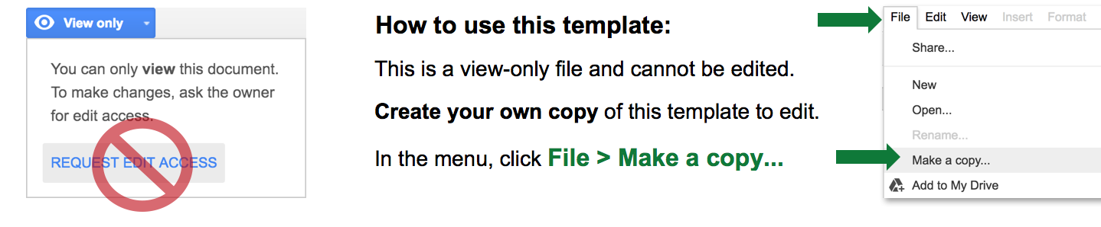

MULTIPLE PROJECT ROADMAP TEMPLATE
Template begins on page 2.

PLANNING
LAUNCHED
APPROVED
OTHER
DEVELOPMENT
OTHER
STATUS KEY

RISK LEVEL

HIGH
MEDIUM
LOW

20XX - Q3 |  |  | 20XX - Q4 |  |  | 20XX - Q1 |  |  | 20XX - Q2 |  |  | 20XX - Q3
JUL | AUG | SEPT | OCT | NOV | DEC | JAN | FEB | MAR | APR | MAY | JUN | JUL | AUG | SEPT
PROJECT 1
 | TEXT  TEXT |  |  | TEXT  TEXT |  |  | TEXT  TEXT |  |  |  | TEXT
PROJECT 2
TEXT |  |  | TEXT  TEXT |  |  |  | TEXT
PROJECT 3
 |  |  |  |  |  |  | TEXT | TEXT |  |  |  | TEXT
PROJECT 4
 | TEXT  TEXT  TEXT |  |  |  | TEXT | TEXT |  |  |  | TEXT

DISCLAIMER

Any articles, templates, or information provided by Smartsheet on the website are for reference only. While we strive to keep the information up to date and correct, we make no representations or warranties of any kind, express or implied, about the completeness, accuracy, reliability, suitability, or availability with respect to the website or the information, articles, templates, or related graphics contained on the website. Any reliance you place on such information is therefore strictly at your own risk.

