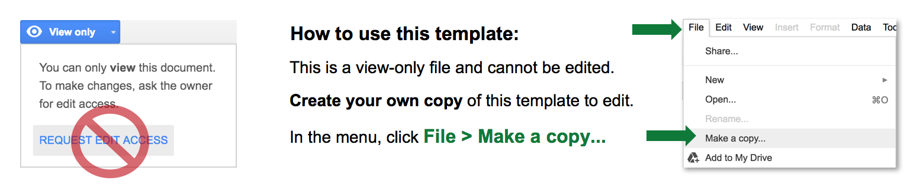

**SAMPLE PROJECT**

**EXECUTION PLAN**



Sample begins on page 2.

For a blank version, use the Smartsheet

Project Execution Plan Template.

**SAMPLE PROJECT EXECUTION PLAN**

|  |  |
| --- | --- |
| PROJECT NAME | PRODUCT BETA LAUNCH |
| PROJECT LOCATION | Acme Akron Headquarters |

|  |  |
| --- | --- |
| COMPANY | Acme Corp. |
| CONTACT NAME | Jane Thompson |
| MAILING ADDRESS | 1118 Acme Dr. N. - Akron, OH 44304 |
| EMAIL | jane.thompson@acmecorp.com |
| PHONE | (330) 763-0982 |

PROJECT SCOPE

|  |
| --- |
| Our competitors have recently been first to market with their competing application and have no significant market competition.  Customer research indicates that the market is ready for our product - but first we must have a test-market / "beta" launch.  Project scope is testing the current beta version of the product in the Akron area. Scope does *not* include testing outside of Akron.  Business objectives of the plan/project are to further test effectiveness / viability of the product in the field and gather new test data from customers. High acceptance / approval rate will indicate eventual higher revenue, and an increase in long-term customers.  Deliverables for the project include meeting - or exceeding - our business objectives by introducing beta version of the product to Akron test market, including the following for customers: instructions, marketing kits, press release, and a small advertising campaign.  Time for beta launch is one week, starting June 1st. Funding for test/beta launch is provided through Marketing.  Assumptions are that we will attain a high customer-satisfaction / approval rating of the beta version, and we will roll out the finalized product in August to markets in and outside of Akron. |

PROJECT GOALS

|  |
| --- |
| Goals of the beta version of the product in the Akron test market are to further test effectiveness / viability of the product in the field and gather new test data from customers. High acceptance / approval rate will indicate eventual higher revenue, and an increase in long-term customers. |

QUALITY SPECIFICATIONS

|  |
| --- |
| Customers will rate their satisfaction with the product on a 1-5 scale - 5 being highly satisfied with the product. Any malfunctions or inconsistencies in the product will be recorded by QA personnel present; these details will then be reported back to development to ensure the finalized product has none of the reported defects. |

TECHNICAL SPECIFICATIONS

|  |
| --- |
| (See Development’s product technical specifications, available on the company’s intranet.) |

RESOURCE ALLOCATION

|  |
| --- |
| Marketing, Dev, Project Management, QA and Product have committed 2 employees from their respective departments to participate in the week-long beta product testing. |

PROJECT SCHEDULE

|  |  |  |
| --- | --- | --- |
| EVENT | PROJECTED START | PROJECTED END |
| Beta Test of Product in Akron Test Market | June 1st | June 7th |

COMMUNICATION PLAN

|  |
| --- |
| The Technical Writing department has provided instructions for product testing.  Marketing has developed marketing kits, a press release, and a small advertising campaign. |

|  |
| --- |
| **DISCLAIMER**  Any articles, templates, or information provided by Smartsheet on the website are for reference only. While we strive to keep the information up to date and correct, we make no representations or warranties of any kind, express or implied, about the completeness, accuracy, reliability, suitability, or availability with respect to the website or the information, articles, templates, or related graphics contained on the website. Any reliance you place on such information is therefore strictly at your own risk. |