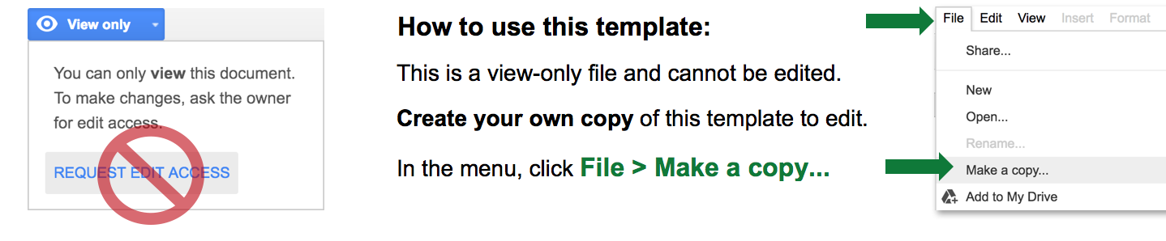
AGILE PROJECT PLAN TEMPLATE
Template begins on page 2.

PROJECT NAME |  |  |  | PROJECT MANAGER
PROJECT DELIVERABLE
SCOPE STATEMENT
START DATE | 00/00/0000 | END DATE | 00/00/0000 | OVERALL PROGRESS | 0%

TASK NAME | ASSIGNED TO | START  DATE | END  DATE | DURATION  in days | STATUS
SPRINT 1 | Alex B. | 09/03 | 09/13 | 10 | Complete
Feature 1 | Frank C. | 09/03 | 09/07 | 4 | Complete
Feature 2 | Jacob S. | 09/07 | 09/12 | 5 | Complete
Feature 3 | Jacob S. | 09/09 | 09/13 | 4 | Overdue
SPRINT 2 | Jacob S. | 09/16 | 09/24 | 8 | In Progress
Feature 4 | Alex B. | 09/16 | 09/17 | 1 | In Progress
Feature 5 | Frank C. | 09/17 | 09/21 | 4 | On Hold
Feature 6 | Shari W. | 09/22 | 09/24 | 2 | Not Started
SPRINT 3 | Shari W. | 09/25 | 10/05 | 10 | In Progress
Feature 7 | Alex B. | 09/25 | 09/29 | 4 | Not Started
Feature 8 | Kennedy K. | 09/24 | 10/02 | 8 | On Hold
Feature 9 | Jacob S. | 10/02 | 10/05 | 3 | Not Started

PROJECT NAME |  |  |  | PROJECT MANAGER
PROJECT DELIVERABLE
SCOPE STATEMENT
START DATE | 00/00/0000 | END DATE | 00/00/0000 | OVERALL PROGRESS | 0%

TASK NAME | ASSIGNED TO | START  DATE | END  DATE | DURATION  in days | STATUS

DISCLAIMER

Any articles, templates, or information provided by Smartsheet on the website are for reference only. While we strive to keep the information up to date and correct, we make no representations or warranties of any kind, express or implied, about the completeness, accuracy, reliability, suitability, or availability with respect to the website or the information, articles, templates, or related graphics contained on the website. Any reliance you place on such information is therefore strictly at your own risk.

